**Input/Outputs**

1. **Login**

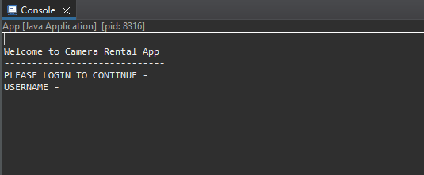

1. **Options to be displayed**

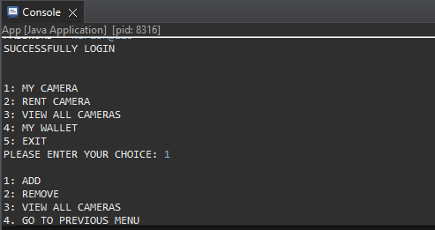

1. **Add camera**

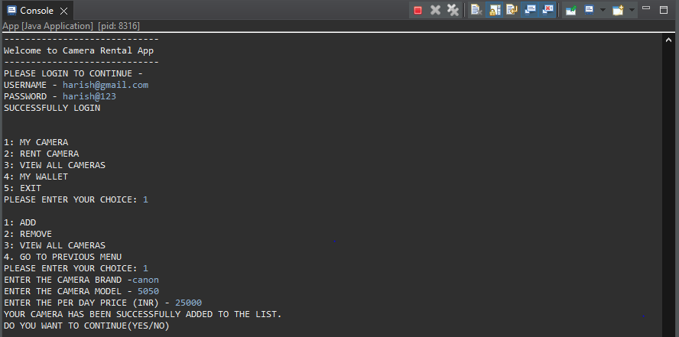

1. **Remove camera**

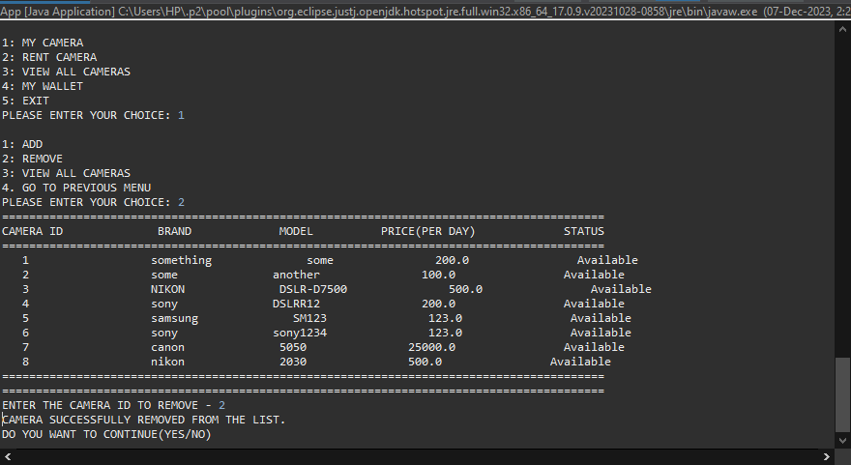

1. **View all cameras**

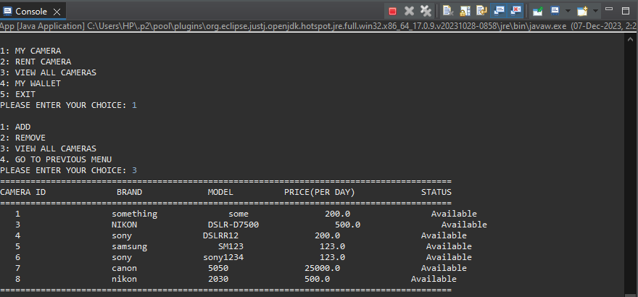

1. **Go to previous menu**

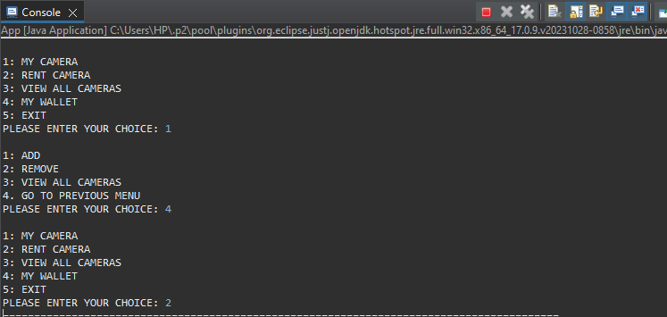

1. **Rent a camera**

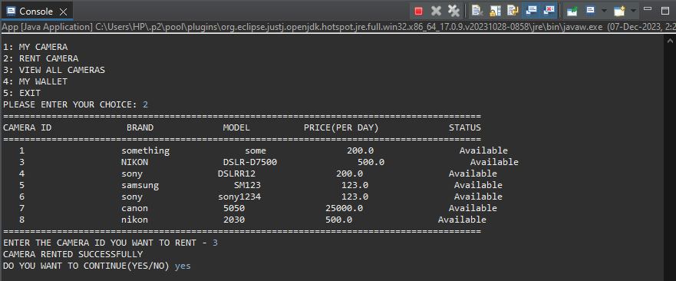

1. **View all cameras**

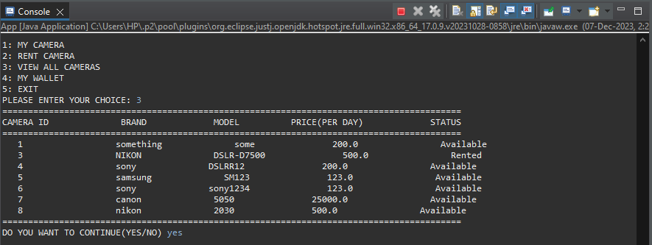

1. **My wallet or add money**

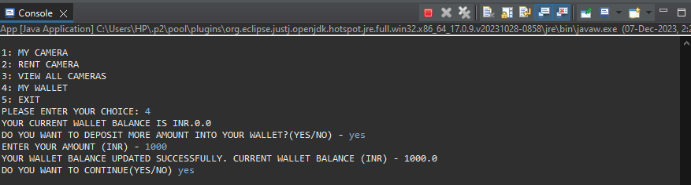

1. **Failed transaction**

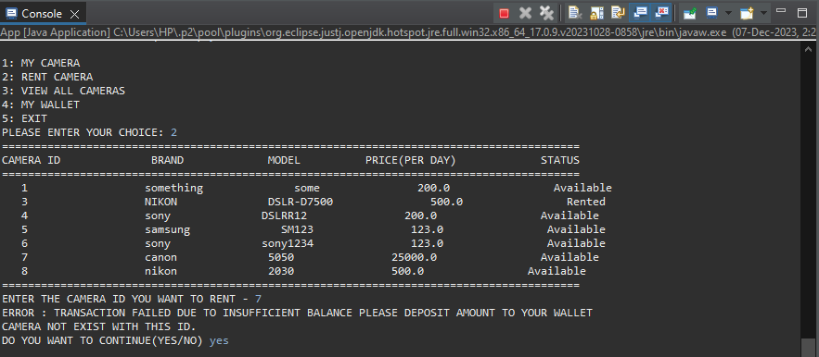

1. **Exit from application**

